Train Driver Persona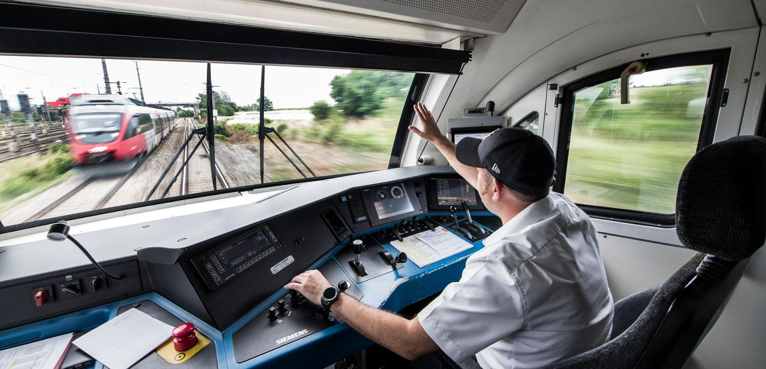

**Name:** Frank Smith

**Age:** 37

**Residence :** Pittsburgh PA

**Occupation:** Train Driver

**Biography(small description of user) :** Frank has beendriving trains for 13 years, and went to school at the Pennsylvania College of Technology for automotive technology. From there he found a newspaper ad for train drivers and decided to apply. Frank has two kids that are 2 and 5.

**Education Level:** Associates Degree Automotive Technology

**Salary Range:** $64,210 - $77,000

**Technology Comfort Level :** Frank owns an iphone and a personal computer. Through his work as a Train Driver, he has gotten used to working with technology due to his job. It takes him a while to learn new technology but he's pretty savvy at it once he knows

**Hobbies :** Golf,hanging out with my young children, play with my cats

**Goals :**

Ebrake has to be very bright and present

Current speed should be large

See any faults that are happening

Touchscreen for non-vital procedures (mostly cabin control // doors)

**Resources :**

Image : <https://blog.railcargo.com/en/artikel/fahrgaeste-oder-gueter>

Demographics : <https://www.zippia.com/train-conductor-jobs/demographics/>

Salary: <https://www.indeed.com/career-advice/finding-a-job/how-to-become-train-driver#:~:text=The%20minimum%20education%20requirement%20to,and%20how%20to%20operate%20it>.